Phase 1:

PROJECT NAME : NOISE POLLUTION MONITORING

Introduction:

Noise pollution is unwanted and unpleasant sound which can deteriorate human health and other living organisms present in the Environment.

There are multiple way from which noise pollution can occur. Major reasons for noise pollution are deforestation, Construction, Air traffic, Road traffic, Population, etc.

Noise Pollution can be divided into 2 types:

1. Man-made Noise
2. Environmental Noise

Project Definition:

Noise or sound level monitoring or measurement is a process to measure the magnitude of Noise in industries and residential area. Data collected from Noise level monitoring & Testing helps us to understand trends and action can be taken to reduce noise pollution. Noise pollution is Low or High-frequency sound that can cause/harm the activity of human life. It can be caused by various industrial Machines, Motor Vehicles and Craft etc. Noise Pollution Monitoring process is a part of Environmental Monitoring & Testing as noise pollution is also increasing exponentially in recent years.

Design Thinking:

Noise level Monitoring Procedure

Noise level measurement procedure are processes which record sound level or acoustic energy level in the specified area. Sound or Noise level meter measures noise in Unit decibel (dB).

Components Required

* Vibration motor/ Buzzer
* Bluetooth HC 05
* Sound sensor module
* Wires
* Arduino Nano

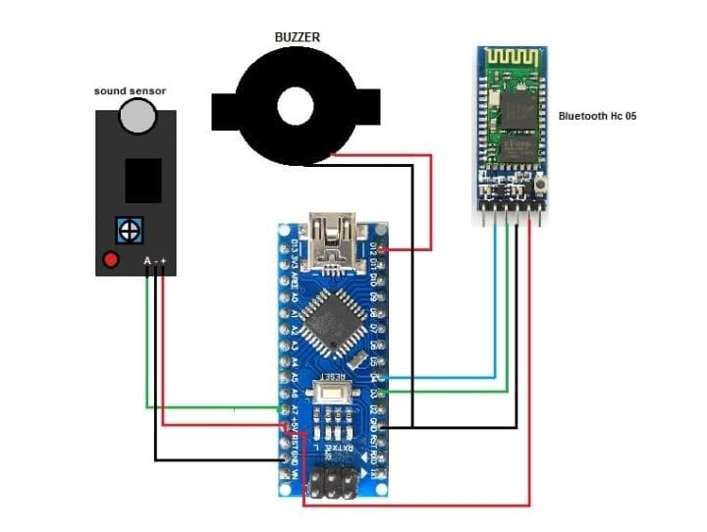

Illustration of connection of components

Power the Arduino and connect the Bluetooth with your app. After successful connection, you can test it by making loud noises. When your sound level crosses the threshold value, the Noise Detector device will buzz to notify about it and at the same time the app will start recording the sound and it will go on recording until the noise level comes down below the threshold level.